Database Management System
19BCA41002
Assignment Task: Analyse ER Diagram & Answer the following Questions.

Topic 1: Bank Database ER Diagram
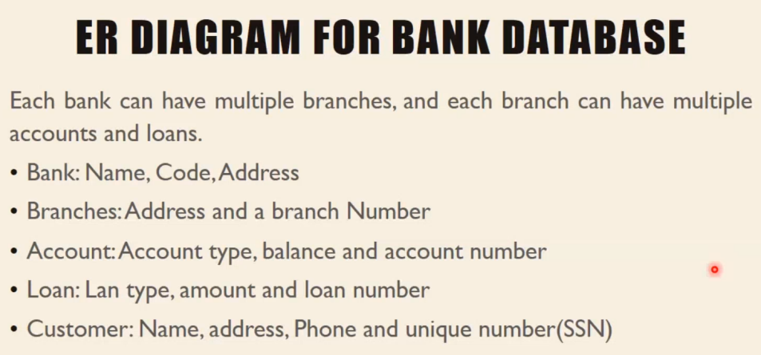
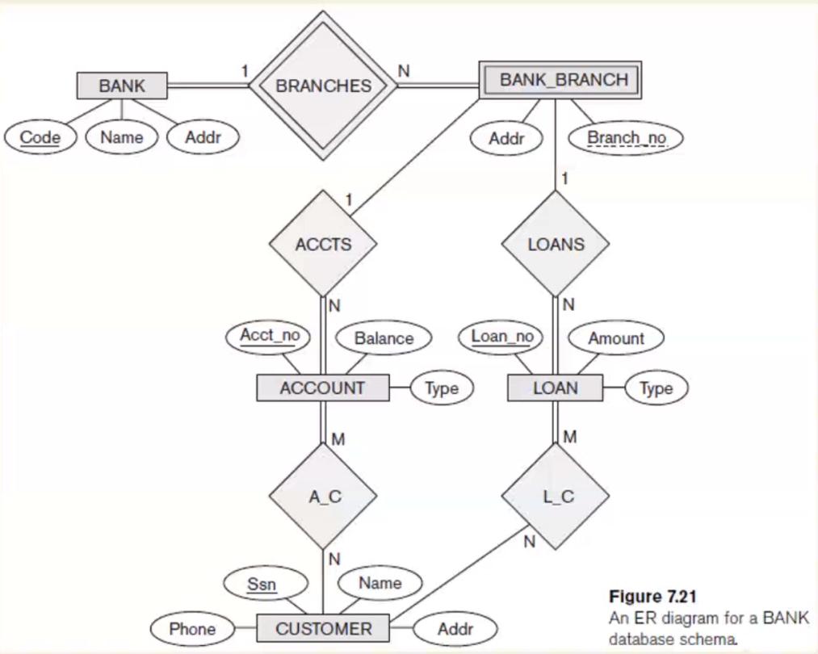
Questions:
Q1. List the strong (non weak) entity types in the ER diagram.
Q2. Is there a weal entity type? If so, give its name, partial key and identifying relationship.
Q3. What constraints do the partial key and the identifying relationship of the weak entity type specify in this diagram?
Q4. List the names of all Relationship types, specify the (min,max) constraints on each participation on an entity type in a relationship type. Justify your choices.
Q5. List Concisely the user requirements that led to this ER Schema Design.
Q6. Suppose that every customer must have at least one account but is restricted to at most two loans at a time, and that a bank branch cannot have more than 1,000 loans. How does this show up on the (min,max) constraints?

Answers:
Ans 1: The Strong entities are as follows:
- Bank
- Account
- Loan
- Customer

Ans 2: Yes, Bank Branch is a Weak Entity as there is total participation of it in Branches, Its partial Key is Branch No:, with the help of which the tuples of the weak entities can be distinguished and identified.
The Identifying Relationship is Branches.

Ans 3: In this diagram, we can observe that the weak entity Bank Branch has a partial key which is called Branch Number:, this partial key helps distinguish a bank branch from the other branches of the same bank with a unique branch number. There is Total Participation of the Weak Entity To the identifying relationship (Branches).

Ans 4: The Relationship types are as follows:
  - Total participation constraint/Existence dependency (Example: As employee can only exist only if we have a department entity)
  - Partial participation constraint (Only a Partial amount of employees are involved with the department)
Sorry explained it with the entities and not the relationship
- Bank-> One bank (1,1) only can have/participate in multiple Bank Branches of that Bank(1,n)
- Bank Branch-> A Single Bank Branch (1,1) from the particular bank can have n number of loans (1,n) within it. Similarly A Single Bank Branch (1,1) from the n number of bank branch from the same bank can have n number of accounts (1,n) within it.
- Account-> Many accounts within the bank branch is related to n number of customers, meaning n number of customers (1,n) are there and each customer can have many accounts(1,n) in the same bank branch.
- Loan-> One of the bank branches can have n number of loans available to the customers thus the loans is related to the bank branch with (1,n) 1 minimum loan and n number of loans allowed.
- Customer-> there can be many customer who can have n number of accounts in the particular bank branch, thus (1,n) customer are related to (1,m) minimum one maximum many accounts.
Similarly with loans (1,n) n number of customers (1,n) can take multiple loans(1,m) related with the loan credentials.
Will try with Relationship:
- Branches: A Bank can have n number of Bank Branches. (1,n)
- Accounts: There can be n number of accounts under a particular bank branch(1,n)
- Loans: There can be N number of Loans under a particular Bank Branch (1,n)
- A.C: N number of customers can have multiple accounts with their Account Credentials (1,n)
- L.C: N number of customers can have multiple Loans in the particular bank branch with their loan credential.

Ans 5: Based on this ER diagram we know that a bank will have multiple bank branches and within that there are bank accounts and loans available for the customers, the customers are linked with their accounts with their account credentials and customers are also linked to loan they may need with their loan credentials.
We can also see how the bank has a unique code to represent its uniqueness among various other banks, then similarly the bank branch, account, loan and customers too have their own key attribute to keep them unique from other similar entities.
Customer
A.C
Account
(1,n)
(1,n)
Ans 6: Custo

Loans
1
Bank Branch
Bank Branch
(1,1000)
Loan

L.C
Customer
Loan
(1,n)
(1,2)

Topic 1:Consider the ER Schema For The Movies Database & Answer True, False or Maybe
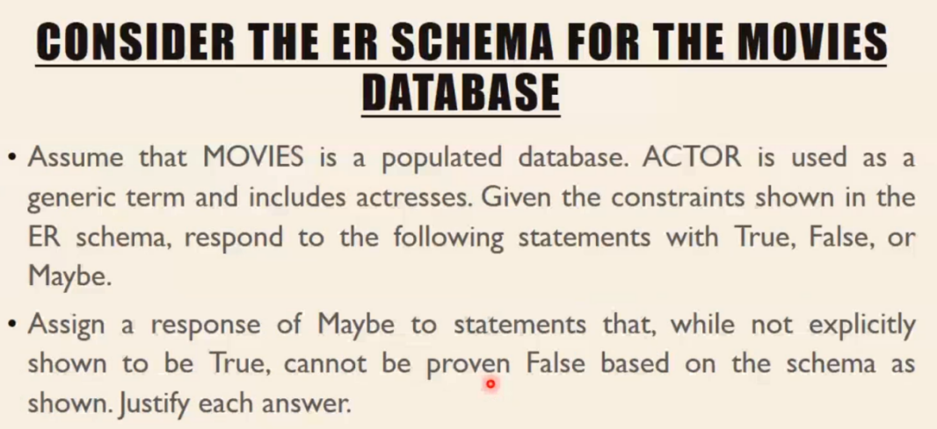
Questions:
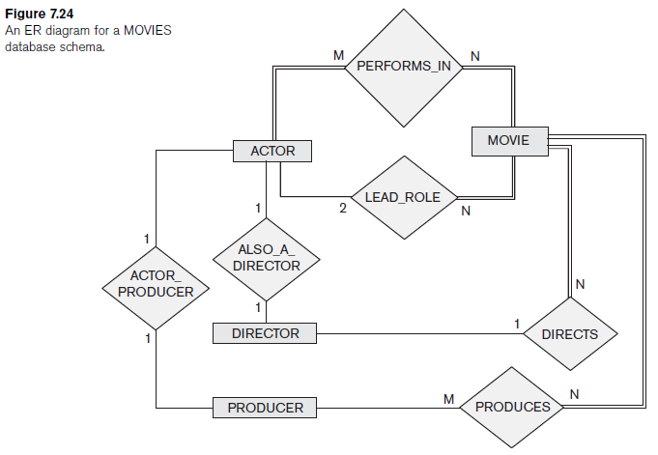
- There are no actors in this database that have been in no movies.
- •There are some actors who have acted in more than ten movies.
- •Some actors have done a lead role in multiple movies.
- •A movie can have only a maximum of two lead actors.
- •Every director has been an actor in some movie.
- •No producer has ever been an actor.
- •A producer cannot be an actor in some other movie.
- •There are movies with more than a dozen actors.
- •Some producers have been a director as well.
- •Most movies have one director and one producer.
- •Some movies have one director but several producers.
- •There are some actors who have done a lead role, directed a movie, and produced some movie.
- •No movie has a director who also acted in that movie.

Answers:
Ans 1- True
Ans 2-Maybe, The there are actors who may have acted in more than 10 movies, but no such data has been displayed in the ER Diagram
Ans 3-True
Ans 4- True
Ans 5-False
Ans 6- False
Ans 7- False
Ans 8- Maybe, There are no specification on the number of actor may be less than a dozen or even more
Ans 9- False
Ans 10- False, according to the ER diagram a movie can have 1 director but multiple producers
Ans 11- False, according to the ER diagram all movies have 1 director and can have many producers
Ans 12-True
Ans 13- False

